
Certificate of Analysis

Product Name： | Acyclovir |  | Packing： |  | 25 kg/drum
Batch No.： | C004026052601 |  | Manufacturing Date： |  | 2026-05-26
Batch Quantity： | - |  | Test Date： |  | 2026-05-29
Storage | Stored in closed container and protected from light |  | Expire Date： |  | 2028-05-25
Test Specification：USP
Test Items |  | Acceptance criteria |  | Tested Results
Appearance |  | A white crystalline powder |  | Conforms
Identification |  | HPLC  IR |  | Conforms  Conforms
Water |  | ≤6.0% |  | 0.94%
Related impurity |  | Guanine≤0.7%  Hydroxyethyl guanine≤0.2%  N⁷-Isomer≤0.1%  Specified impurity 1≤0.1%  Specified impurity 2≤0.3%  7,9'-Diguanyl analog≤0.1%  9,9'-Diguanyl analog≤0.2%  Acyclovir related compound F≤0.1%  Acyclovir related compound A≤0.1%  Diacetyl guanine≤0.1%  Bis-acyclovir≤0.2%  Acyclovir related compound G ≤0.1%  Any unspecified impurity≤0.05%  Total impurities≤1.0% |  | 0.20%  0.01%  ND  0.01%  0.02%  ND  ND  ND  ND  ND  0.02%  ND  0.03%  0.30%
Assay by HPLC |  | 98.0%~102.0% |  | 99.8%
Note: N.D indicates “Not detected“

Conclusion: Complies With USP -NF 2025.
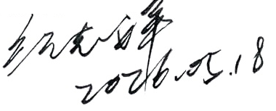
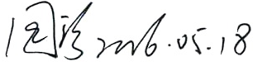
Reporter/Date： | 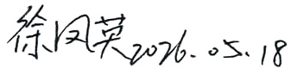  Reviewer/Date： | QA Head/Date：

